Towards Agent-Based Modeling in Data-Scarce Megacities: A Case Study of Dhaka

*[Author Name]
[Degree, e.g. M.Sc. Student / Ph.D.], Department of [Department]
[University], [City, Country]
Email: [author email]
ORCID: [https://orcid.org/0000-0000-0000-0000]
[Co-Author Name]
[Degree/Position], Department of [Department]
[University], [City, Country]
Email: [co-author email]
ORCID: [https://orcid.org/0000-0000-0000-0000]
………..
*Corresponding author
Word Count:

ABSTRACT

- INTRODUCTION (Tasnia Prima)

Transportation plays an important role in the daily life of people and in the economic growth of a country. Modern transportation requires looking beyond broad traffic patterns. It requires looking at the individual. Agent-Based Models simulate each traveler as an individual agent with their own personal and household characteristics. Each agent makes travel decisions based on factors such as age, gender, occupation, income, household size, vehicle ownership, and workplace location. By modeling travelers individually, ABMs can better represent travel behavior, traffic congestion, and interactions among different transport modes. Software platforms such as MATSim (Horni et al., 2016) have become popular for building large-scale agent-based transportation models because they can simulate the daily activities and travel choices of millions of people in a realistic way. A key requirement for building an agent-based model is the availability of a synthetic population. A synthetic population is an artificial but statistically representative population whose characteristics closely match those of the real population. It includes both household attributes, such as household income, household structure, and vehicle ownership, and person attributes, such as age, gender, employment status, and workplace location. These characteristics strongly influence travel behavior and therefore are essential for realistic transportation simulations.
In Global South Asia the transportation system is under increasing pressure because of rapid population growth, urbanization, and the rising demand for travel. As the city continues to grow, traffic congestion, long travel times, and inefficient public transport have become major challenges. To solve these problems, transportation planners need reliable tools that can accurately represent how people travel and how different transport policies may affect their travel behavior.
However, collecting detailed information for every individual in a large city is almost impossible due to privacy concerns, high costs, and limited data availability. Instead, researchers usually conduct Household Travel Surveys (HTS) that collect detailed information from a small sample of households. The survey data are then combined with aggregate census information to generate a complete synthetic population.
Several methods have been developed for population synthesis, including Iterative Proportional Fitting (IPF), Bayesian Networks, Markov Chain Monte Carlo (MCMC), Combinatorial Optimization, and Iterative Proportional Updating (IPU). Among these methods, IPU has become widely used because it can simultaneously match both household-level and person-level attributes while maintaining consistency across different geographical areas. This makes it particularly suitable for developing realistic synthetic populations for large urban regions.
Although population synthesis methods have been successfully applied in many developed countries, applying them in Global South Asian Region remains challenging because of limited data availability. Many existing modeling frameworks rely on detailed datasets such as standardized public transport schedules (GTFS), high-resolution census records, building databases, and accurate transport networks. Unfortunately, these datasets are either incomplete, unavailable, or only available in aggregated form for particular city. As a result, previous transportation models often had to simplify public transport operations instead of representing actual network movements, reducing the accuracy of the simulation results.
This study aims to address these challenges by developing a synthetic population for Dhaka using the Iterative Proportional Updating (IPU) method and available census and survey data along with generating a self-built GTFS for transit system. By matching both household and person characteristics with census distributions, the generated synthetic population can provide a more realistic representation of the city's residents. This population can then be used as the foundation for agent-based transportation models, allowing researchers and policymakers to evaluate transportation policies, infrastructure investments, and future mobility scenarios more accurately. The proposed approach demonstrates how population synthesis can support transportation planning in data-scarce developing cities like Dhaka and contribute to more informed and effective decision-making.

2. Background & Related Works (Adnan Abir)
Transportation systems are fundamentally composed of physical infrastructure, management frameworks, and a set of interconnected transport modes and operators (Ortuzar & Willumsen, 2011). Historically, aggregated four-step models have been used as the standard methodology for evaluating the impacts of transportation policies and new infrastructure investments. However, these traditional models fall short in capturing individual decision-making processes and the complex interactions between travelers. Crucially, they fail to account for the underlying principle that travel demand is intrinsically derived from the need to perform daily activities.
Consequently, agent-based models (ABMs) have gained significant traction in transportation science across developed, developing, and under-developed contexts. ABMs simulate the microscopic behavior of individual agents, explicitly modeling their competition to access and utilize transport infrastructure. This disaggregated approach enables the accurate representation of congestion patterns and the intricate interactions within modern multimodal ecosystems, where diverse mobility services simultaneously compete and complement one another. Furthermore, ABMs facilitate the analysis of highly dynamic transportation services on much finer temporal resolutions than conventional activity-based models can provide.
In spite of their computational power, microscopic models such as MATSim (Multi-Agent Transport Simulation) impose heavy data requirements. Highly detailed inputs are mostly required - synthetic population with discrete daily activity chains and a high-resolution, multimodal transport supply network. While standardized, open-source pipelines - such as the Eqasim framework - have been developed in translating raw census and survey data into simulation-ready inputs, they predominantly work in a data-enriched environment. These pipelines rely heavily on established General Transit Feed Specification (GTFS) data, official building registries, and micro-level census tracts. In developing megacities like Dhaka, such datasets are either highly fragmented, aggregated at unusable administrative scales, or entirely absent.
In the cases where abundant data are easily available, researchers have successfully leveraged highly structured datasets to build efficient ABMs. For instance, Hörl and Balac (2021) introduced an open-source pipeline to generate synthetic populations from raw data, initially applying it to the Île-de-France region around Paris. Their methodology utilized a combination of national census data, regional and national household travel surveys (HTS), tax registries, and comprehensive open-source facility data. The modularity of this pipeline has enabled its subsequent adaptation for large-scale models in California and Switzerland.
Similarly, Ruan et al. (2025) constructed a Digital Urban Mobility Twin for Washington, D.C., utilizing open Census and OpenStreetMap (OSM) data to evaluate pandemic-induced shifts in mobility patterns. Pereira et al. (2022) extended the Eqasim framework for Ústí nad Labem, Czech Republic, incorporating high-fidelity building floor-plan capacities and synthetic boundary gates to accurately capture regional commuting flows. These studies underscore the efficacy of established population synthesis pipelines when supported by robust, high-resolution geospatial and demographic inputs.
Conversely, deploying ABMs in data-scarce environments requires significant methodological modification. To overcome severe data limitations in Carinthia, Austria, Felbermair et al. (2020) utilized Bayesian networks and Markov Chain Monte Carlo (MCMC) simulations to extrapolate activity chains from a minimal travel survey, anchoring destination choices via OSM spatial cell potentials.
Within the specific context of Dhaka, recent efforts have begun to apply MATSim to complex urban mobility challenges. Zannat et al. (2024) implemented a MATSim mode-choice model to forecast demand for the city's Bus Rapid Transit (BRT) system. However, constrained by the absence of reliable transit route information and standardized GTFS data, their simulation was forced to rely on the MATSim "teleportation" module for public and non-motorized transport. This approach estimates travel times without explicitly routing vehicles through the network, thereby bypassing true network-based transit behavior.
This paper addresses these critical methodological gaps in the modeling of data-scarce developing cities. By synthesizing a rigid GTFS feed utilizing routing APIs and circumventing the limitations of aggregated census data through a direct, census based Iterative Proportional Updating (IPU) approach, this methodology eliminates the reliance on transit teleportation. The result is a fully network-routed, multimodal foundation capable of accurately simulating Dhaka's complex transportation ecosystem.

3. STUDY AREA (Adnan Abir)
The study area comprises Dhaka North City Corporation (DNCC) and Dhaka South City Corporation (DSCC), plus the adjoining Savar and Keraniganj upazilas (sub-urbans), which contribute substantial commuting population but fall outside the two city corporations' administrative boundaries. DNCC and DSCC each maintain an independent, overlapping ward-numbering scheme, so this paper adopts a combined zoning code - an S or N prefix plus a two-digit ward number (e.g., S07, N54) - with Savar and Keraniganj each represented as a single coarse zone. This yields 130 city-corporation wards (75 in DSCC, 55 in DNCC, the latter including one restricted cantonment area) plus the two sub-urbans (DSU).
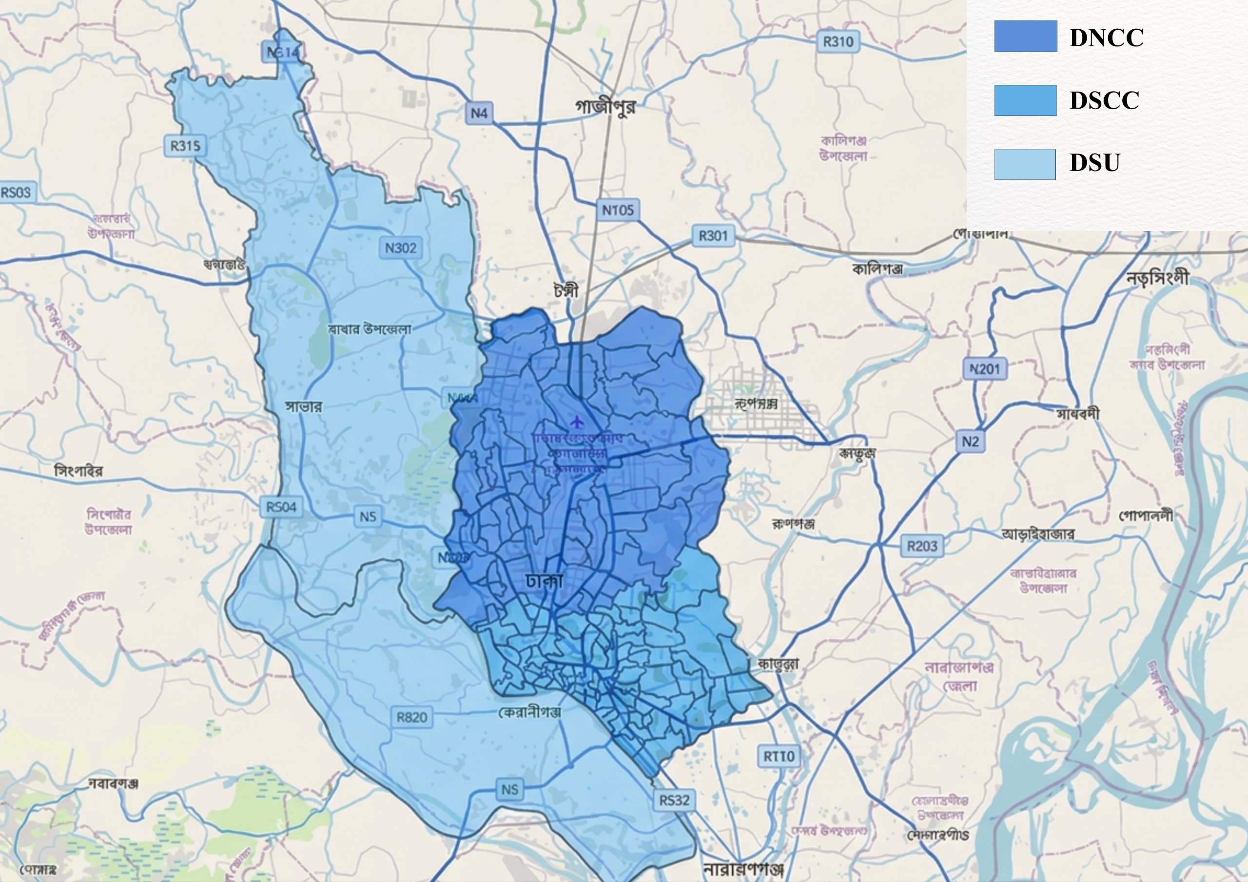
Figure 1. Ward-wise Study Area. Background map © OpenStreetMap contributors
5. Methodology (Adnan Abir)
In this work, raw survey, census, and geospatial data for Dhaka are transformed into a MATSim-ready synthetic population and mobility scenario through five stages: input preparation, population synthesis, activity-location assignment, schedule assembly, and scenario assembly. Five data sources are drawn on in parallel - the DTCA household travel survey, the BBS 2022 census, ward administrative boundaries, a nationwide OpenStreetMap building extract, and a self-built GTFS transit feed paired with an OpenStreetMap road network. Each source is first cleaned and spatially reconciled on its own terms. Survey trip purposes, modes, and distances are recoded and resolved against ward geometry. The census tables are extracted from source documents and cross-validated internally. The two city corporations' independent ward-numbering schemes are unified into a single identifier space and buildings are classified into candidate activity types.

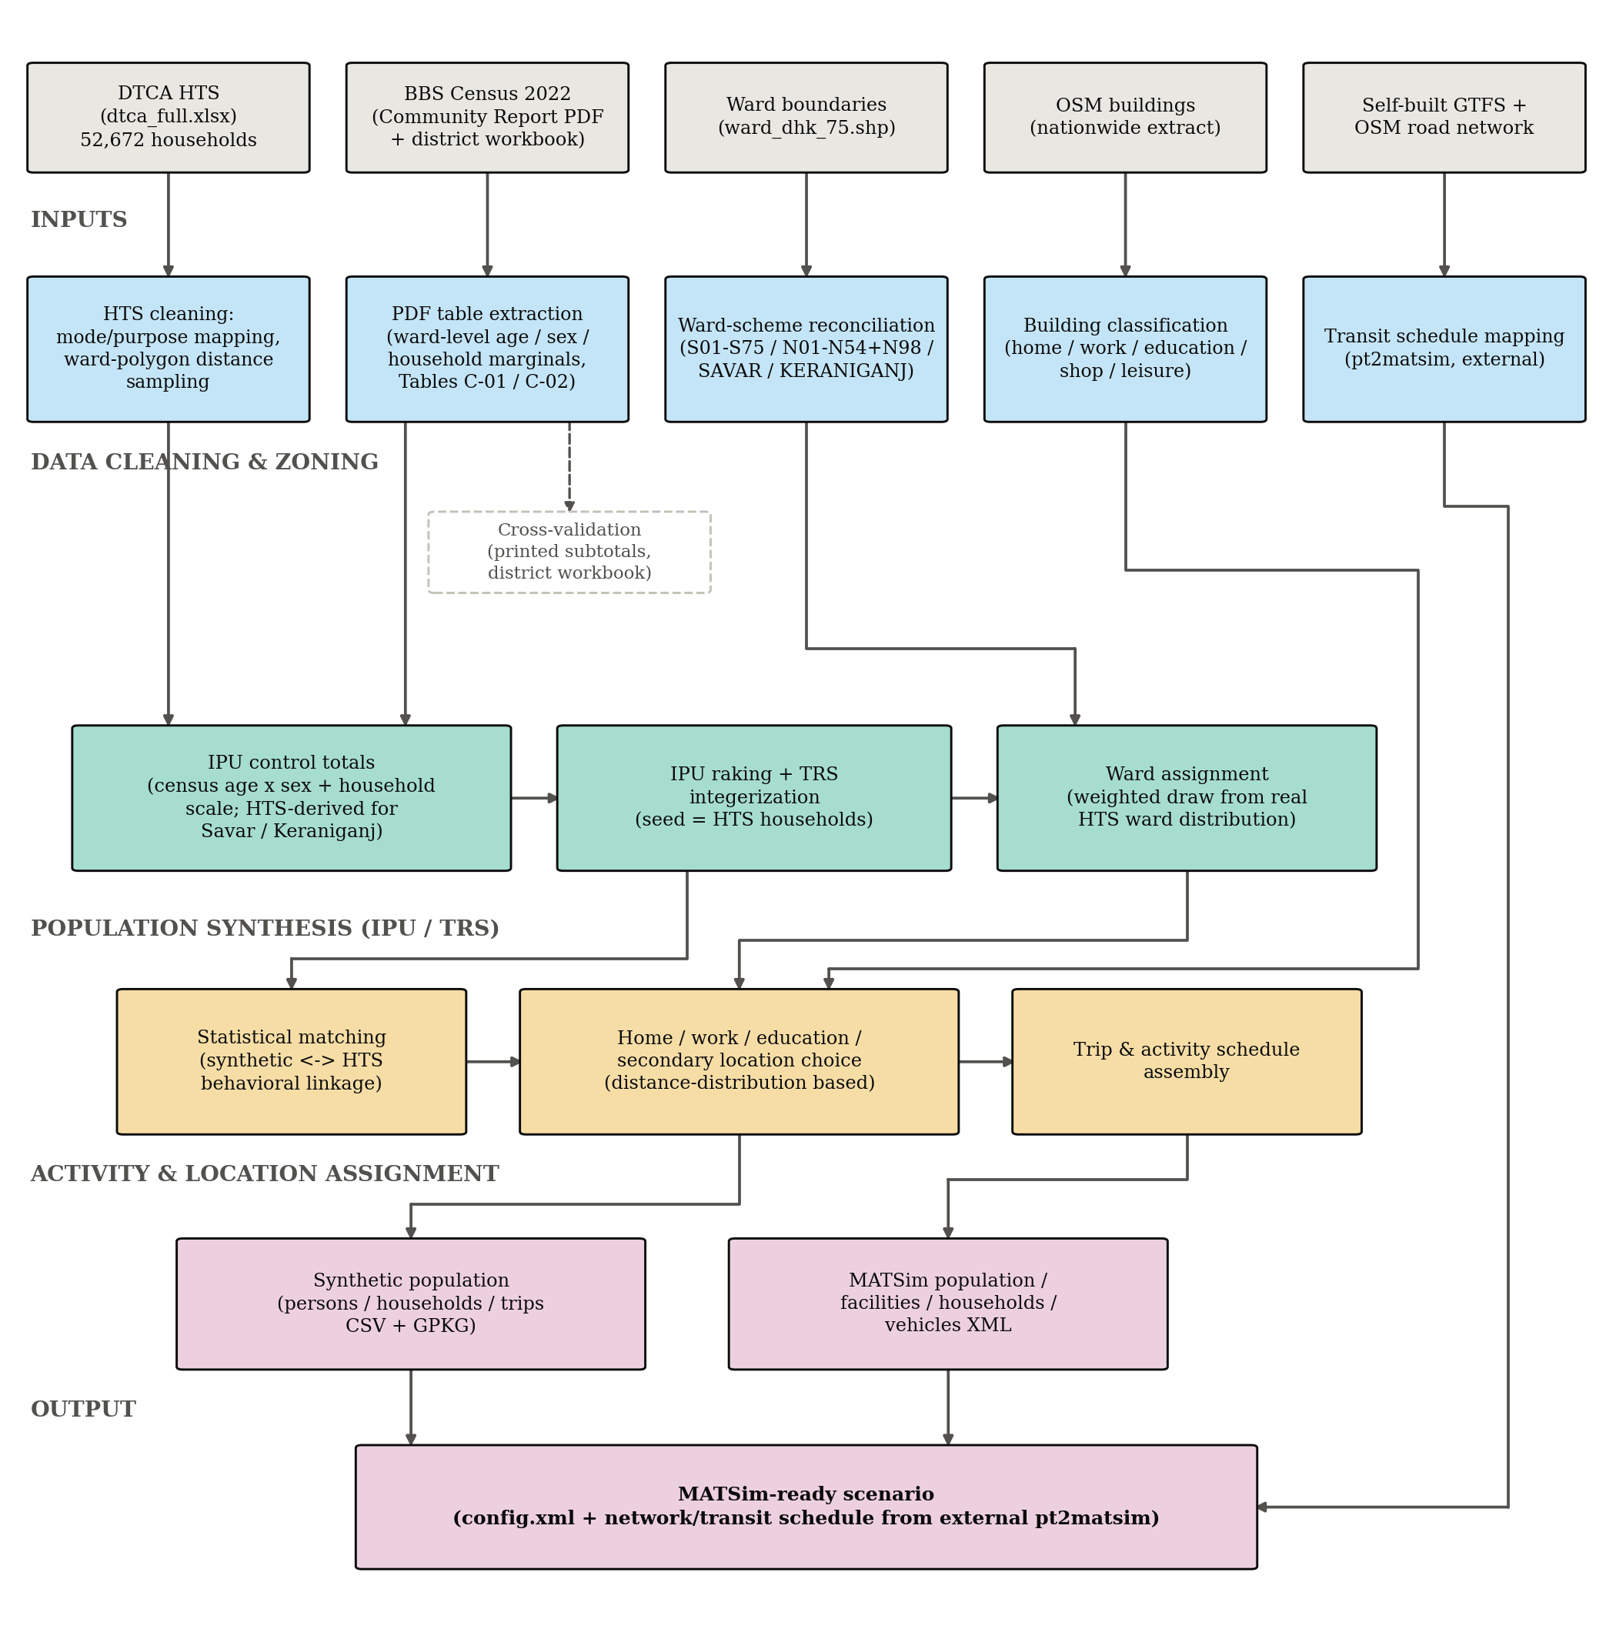
Figure 2. Overview of the Dhaka data preparation pipeline.
These prepared inputs then drive population synthesis proper: census-derived control totals for age, sex, and household size - falling back to survey-derived totals only where no ward-level census coverage exists - are used to reweight the household travel survey sample itself via Iterative Proportional Updating, followed by Truncate-Replicate-Sample integerization into a discrete synthetic household population. Each synthetic household is subsequently assigned a ward through a weighted draw from the real census ward distribution, linked back to the survey behaviorally through statistical matching, and given home, work, education, and secondary activity locations through distance-distribution-based matching against the classified building and OpenStreetMap candidate pool. A full daily activity and trip schedule is then assembled for every synthetic person. Finally, this demand-side output is combined with an independently prepared supply side - a road network and transit schedule built externally via pt2matsim - to produce a complete MATSim-ready scenario. The remainder of this section details each of these stages in turn.
5.1. Population Synthesis
The synthesis of the Dhaka population was executed using an adapted version of the open-source ‘eqasim’/ ‘synpp’ pipeline framework (Hörl & Balać, 2021). This approach establishes direct methodological continuity with established synthetic populations, including those developed for Île-de-France (Hörl & Balać, 2021), California (Balać & Hörl, 2020), and São Paulo (Sallard et al., 2020). Architecturally, the framework models the population synthesis process as a directed acyclic graph (DAG) of processing stages.
Following the structural logic outlined by Sallard et al. (2020), the modeling pipeline is operationalized across four distinct sequential phases:

Figure 3. 4 broad phases of Population Synthesis
5.1.1. Pre-processing the input data
- Data Sources:
The Dhaka Transport Coordination Authority (DTCA) household travel survey is a cross-sectional survey of 52,672 households (186,988 individually listed household members) across Dhaka and adjoining districts, with 380,092 recorded trip legs. Unlike a single-respondent survey design, where non-respondent household members must be statistically imputed, the DTCA survey lists every household member directly, with age, sex, employment status, education level, and driving license already recorded for each person. Restricting to the study area and applying data-quality filters yields 38,092 households, 133,335 persons, and 276,060 trips. Each household carries a survey expansion factor, used both as the initial seed weight for population synthesis and, before census integration, as the sole basis for control totals.
Bangladesh's 2022 Population and Housing Census (Bangladesh Bureau of Statistics, 2022) is available in two forms. A district-level workbook gives population, sex ratio, and a household-size distribution for the whole of Dhaka district, which also includes areas well outside the study area and so cannot directly supply control totals without misrepresenting scale. The Bangladesh Bureau of Statistics Community Report for Dhaka, by contrast, tabulates population down to the ward level for DNCC and DSCC specifically, but only as a 1,668-page PDF with no accompanying structured data file. To recover a usable data set from this PDF, ward-level population, sex, and age-group subtotals were extracted programmatically using pattern-based parsing of each ward's printed subtotal rows, rather than manual transcription. This extraction was cross-validated internally: the two relevant tables (household/population/sex by ward, and population by age group by ward) independently agree on every ward's population total, and the resulting ward-level sums reproduce the report's own printed city-corporation subtotals exactly.
Ward boundaries come from a shapefile matching the survey's post-2020 75-ward DSCC numbering. Building footprints come from a nationwide OpenStreetMap-derived extract (11,021,578 polygons), of which fewer than 1% carry a usable land-use type tag, and which is therefore supplemented with point-of-interest data read directly from a Bangladesh OpenStreetMap extract (Section 5.1.3). No official Bangladesh GTFS feed exists for Dhaka; one was constructed and independently cross-validated for this study (Section 5.2), after which the resulting network and schedule were matched using pt2matsim (matsim-org, 2016) outside this pipeline.

- Trip Purpose & Mode Categorization:
Trip purposes were collapsed into four fundamental categories (home, work, education, other) by parsing the directional keywords in the survey data. For transport modes, the conventional five-category framework was expanded to seven (walk, bike, rickshaw, paratransit, car, public transport, and other) to accurately reflect the local non-Western mobility context. Most notably, rickshaw (which comprises roughly a third of all recorded trips) and paratransit were retained as distinct categories. Aggregating these locally dominant modes into standard Global North classifications would have materially distorted the mode-share validation.

- Employment, license, and income categorization:
Employment status, student status, and driving-license possession were derived directly from observed survey responses rather than imputed or matched against external registries. This provides a methodological simplification compared to the standard pipeline, which relies on Bernoulli-calibrated imputation for license possession. Additionally, household income was structured as an ordinal variable based on reported local currency (Taka) brackets.

Table 1. Data typically assumed by open-data agent-based modeling pipelines, and this study's strategy for each gap in Dhaka's data environment.
Data set | Assumed by open-data ABM pipelines (e.g., 2) | Status for Dhaka / this study's strategy
Weighted census microsample | Large (e.g., 30%) weighted household sample | Not available; hybrid IPU raking of the survey sample (Section 5)
Fine-grained census | Structured microsample and/or aggregate tables | 1,668-page unstructured PDF; extracted and cross-validated (Section 5)
Household travel survey | Often single respondent per household | Full household roster (52,672 hh.)
Commuting O-D matrix | Municipality-to-municipality flow matrix | Not available; distance-distribution location matching (Section 5)
Building / facility registry | Separate address, enterprise, facility censuses | <1% land-use typed; supplemented with OpenStreetMap POIs (Section 5)
Household income | Often a spatial proxy (e.g., municipal decile) | Real, per-household survey bracket

- Spatial referencing:
Administrative wards from the DNCC and DSCC city corporations serve as the finest available zoning units. To resolve overlapping numbering schemes between the two municipalities, zone identifiers were prefixed by their respective city corporation (e.g., S07, N54). Additionally, the peripheral upazilas of Savar and Keraniganj were modeled as single, coarse zones due to the absence of finer administrative subdivisions in the survey data.

Table 2. Collapse of raw DTCA survey mode categories into seven synthesis modes.
Synthesis mode | Example raw DTCA categories
Walk | Walking
Bicycle | Bicycle
Car | Private car, microbus, jeep, motorcycle, taxi, ride-share car, staff vehicle, truck/pickup
Public transport | Bus, mini bus, staff bus, school/college bus, school van, laguna/tempu, metro rail, train, boat
Rickshaw | Rickshaw (man/cycle-pulled non-motorized three-wheeler)
Paratransit | CNG/auto three-wheeler (shared or reserved)
Other | All remaining/unclassified categories

5.1.2. Creating Synthetic Households:
The pipeline synthesizes households by reweighting the travel survey sample against independent control totals using Iterative Proportional Updating (IPU; Ye et al., 2009) and Truncate-Replicate-Sample (TRS; Lovelace & Ballas, 2013) integerization. This approach was selected over direct census expansion due to the unavailability of individual-level census microdata for Dhaka. Because only tabulated ward-level summary counts are available, IPU provides the optimal methodology for matching marginal control totals.
- Control Totals:
To construct the IPU control totals, two independent census sources were combined across varying spatial resolutions. Primary ward-level marginals - including household counts, population by sex, and population by age groups - were extracted from the BBS 2022 Community Report. District-level census data was utilized and rescaled to match local household counts as household-size distributions were unavailable at the ward level. The Household Travel Survey (HTS) was used as a fallback for peripheral zones (Savar and Keraniganj). Additionally, data constraints caused two methodological simplifications. One, the synthetic population was restricted to individuals aged five and older to align with the HTS roster, and the other, joint age-by-sex control totals were calculated using the outer product of independent marginals, as explicit cross-tabulations were absent from the census tables.
- IPU Formulation:
Let $w_{h}^{\left(0\right)}$ represent the initial sample weight (survey expansion factor) of household h, and 𝒞 denote the set of control-total categories. For each category c ∈ 𝒞 with a target total $T_{c}$ the IPU algorithm calculates an adjustment factor at each iteration t:
$f_{c}^{\left(t\right)}$ = $\frac{T_{c}}{\sum_{h:h∈c}{w_{h}^{\left(t\right)}}}$
The weights for every household matching category c are then updated accordingly:
$w_{h}^{\left(t+1\right)}$ = $w_{h}^{\left(t\right)}$· $f_{c}^{\left(t\right)}$ for all h ∈ c
This process iterates across all categories in 𝒞 until the weighted total for every category converges within a predefined tolerance (e.g., ${10}^{-3}$, with a maximum of 300 iterations).
- Truncate-Replicate-Sample (TRS) integerization:
Because Iterative Proportional Updating (IPU) generates continuous, non-integer household weights, the Truncate-Replicate-Sample (TRS) method is employed to discretize these values into a concrete, whole-number population. In this procedure, each household's adjusted weight $\left(w_{i}\right)$ is partitioned into an integer replication count and a fractional remainder. The integer portion deterministically dictates the baseline number of household replicas, while the fractional remainders are resolved through weighted random sampling to exactly match the target control totals. Following the stochastic rounding formulation outlined in (Lovelace & Ballas, 2013), the integer multiplier ($m_{i})$ for each household is determined as:
$m_{i}$= $\left\{\begin{aligned}\left\lfloor w_{i}\right\rfloor with probability 1-(w_{i}- \left\lfloor w_{i}\right\rfloor ) \\ \left\lfloor w_{i}\right\rfloor +1 with probability w_{i}- \left\lfloor w_{i}\right\rfloor \end{aligned}\right.$
Consequently, every synthetic household operates as a discrete, direct replica of an observed survey household rather than a statistical composite of multiple observations.
At full census expansion, this integerization process scales the underlying survey sample of approximately 38,000 households into a synthetic population of roughly 2.7 million households. Conversely, a standard 1% configuration proportionally generates about 34,000 households, representing 118,000 individuals. To ensure computational tractability at the full census scale, the replication framework is executed using a highly optimized, vectorized array-gather operation rather than iterative per-replica loops.
5.1.3. Imputing Primary Locations:
OpenStreetMap (OSM) building-polygon extract and local point-of-interest (POI) with amenity data were used for activity location as spatial candidates. Because explicit type classifications are exceedingly sparse within the raw building dataset, the supplementary POI records served as the primary basis for identifying work, education, commercial, and leisure facilities. The vast majority of unclassified building footprints were subsequently designated as residential candidates and, following established heuristics for untyped registries, were constrained to a plausible floor-area range of 40 to 400 m².
Following this spatial classification, each synthetic household was allocated a specific home location by randomly drawing from the available pool of residential candidates situated strictly within its assigned administrative ward.
To assign work and education destinations, a distance-matching approach was employed based on empirical target-distance distributions derived from the household travel survey. For each synthetic individual, a k-d tree nearest-neighbor search was utilized to identify the specific facility whose distance from the assigned home location most closely aligned with a probabilistically drawn target distance. The integration of the supplementary OSM amenity data significantly enhanced this spatial matching process, elevating the overall education-location assignment success rate to approximately 91%.
5.1.4. Imputing Secondary Locations:
Secondary activity locations (such as shopping and leisure) were assigned using the CARLA relaxation-discretization algorithm (Hörl & Axhausen, 2020). Consistent with the Seville and Île-de-France pipelines, this approach iteratively maps continuous spatial assignments to the discrete pool of available facility candidates. The algorithm optimizes these locations to ensure that the resulting trip geometries closely reproduce the distance and transport mode distributions observed in the household travel survey. Because this methodology generalizes effectively across contexts, the baseline pipeline implementation was applied directly without requiring Dhaka-specific modifications.
5.2. GTFS Generation
In many emerging megacities, the absence of standardized, authoritative public transit data (such as GTFS feeds) presents a critical barrier to agent-based transport modeling. To overcome this limitation, a transferable, multi-source data fusion methodology was developed to construct and validate a complete transit schedule from fragmented, unstandardized records. This approach provides a scalable blueprint for transit supply synthesis in other data-scarce contexts where conventional data inputs are unavailable.

5.2.1. Digitization and Frequency-Based Scheduling:
The foundation of the synthetic transit feed was established by digitizing legacy, non-machine-readable route inventories. Because transit operations in informal or rapidly developing networks typically follow frequency-based dispatching rather than strict timetabling, the network was modeled using a uniform headway structure. By implementing a standardized service interval (a uniform 10-minute headway from 05:00 to 23:00), this framework successfully approximates the operational rhythm of informally scheduled bus services without requiring unattainable empirical departure logs. This headway-based approach is highly transferable to other paratransit-dominant networks.
5.2.2. Empirical Travel Time Imputation:
A major challenge in synthetic schedule generation is establishing realistic inter-stop travel times without extensive field observation. In order to pull realistic driving durations between consecutive stops, this methodology utilizes open-source routing APIs (such as OpenRouteService). This approach bridges the gap between free-flow passenger vehicle routing and real-world transit congestion, offering a calibratable mechanism which is easily adaptable to the mixed-traffic conditions of other cities.
Following the synthesis of the complete GTFS feed, the structured data was processed using ptMapper to translate the scheduled routes into a MATSim-compatible format. This integration successfully generated the requisite transit schedule, defined the transit vehicle fleet, and mapped the spatial network topology. Ultimately, this pipeline produced a fully functional, simulate-able synthetic public transit system tailored specifically for the Dhaka metropolitan area.

6. VALIDATION RESULTS
Figure 3 compares the age distribution (in 5-year bins) of the synthesized population against the ward-level census controls and the household travel survey (HTS). Because age and sex are controlled dimensions during the synthesis process, the generated population tightly matches the census, with deviations remaining below 0.3 percentage points across all age cohorts.
On the other hand, in the 20–24 and 25–29 age bins, the HTS exhibits visible discrepancies over-representing the former and under-representing the latter by approximately 1.0 to 1.5 percentage points relative to the census. As the synthesized population is anchored strictly to census marginals, these most likely reflect age-heaping or misreporting within the HTS rather than actual demographic characteristics. Consequently, both the age structure and sex ratio of the final synthetic population accurately reproduce the authoritative census data.
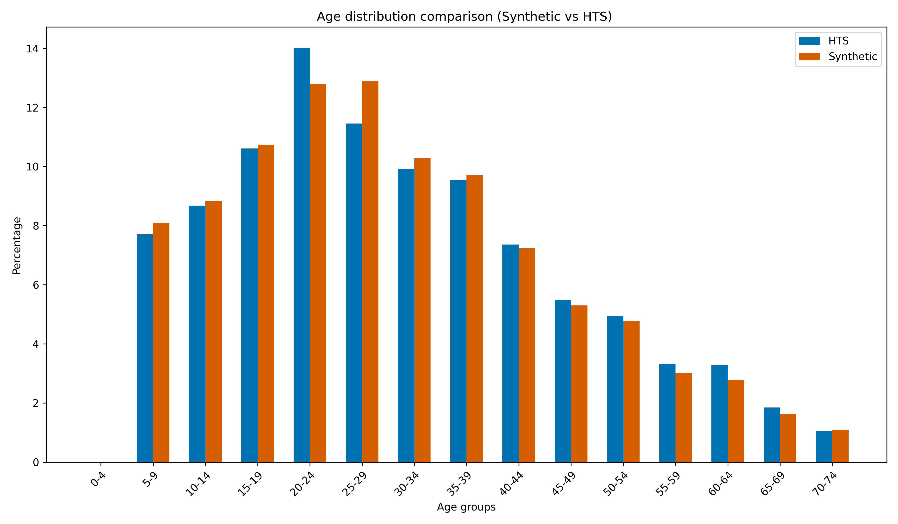
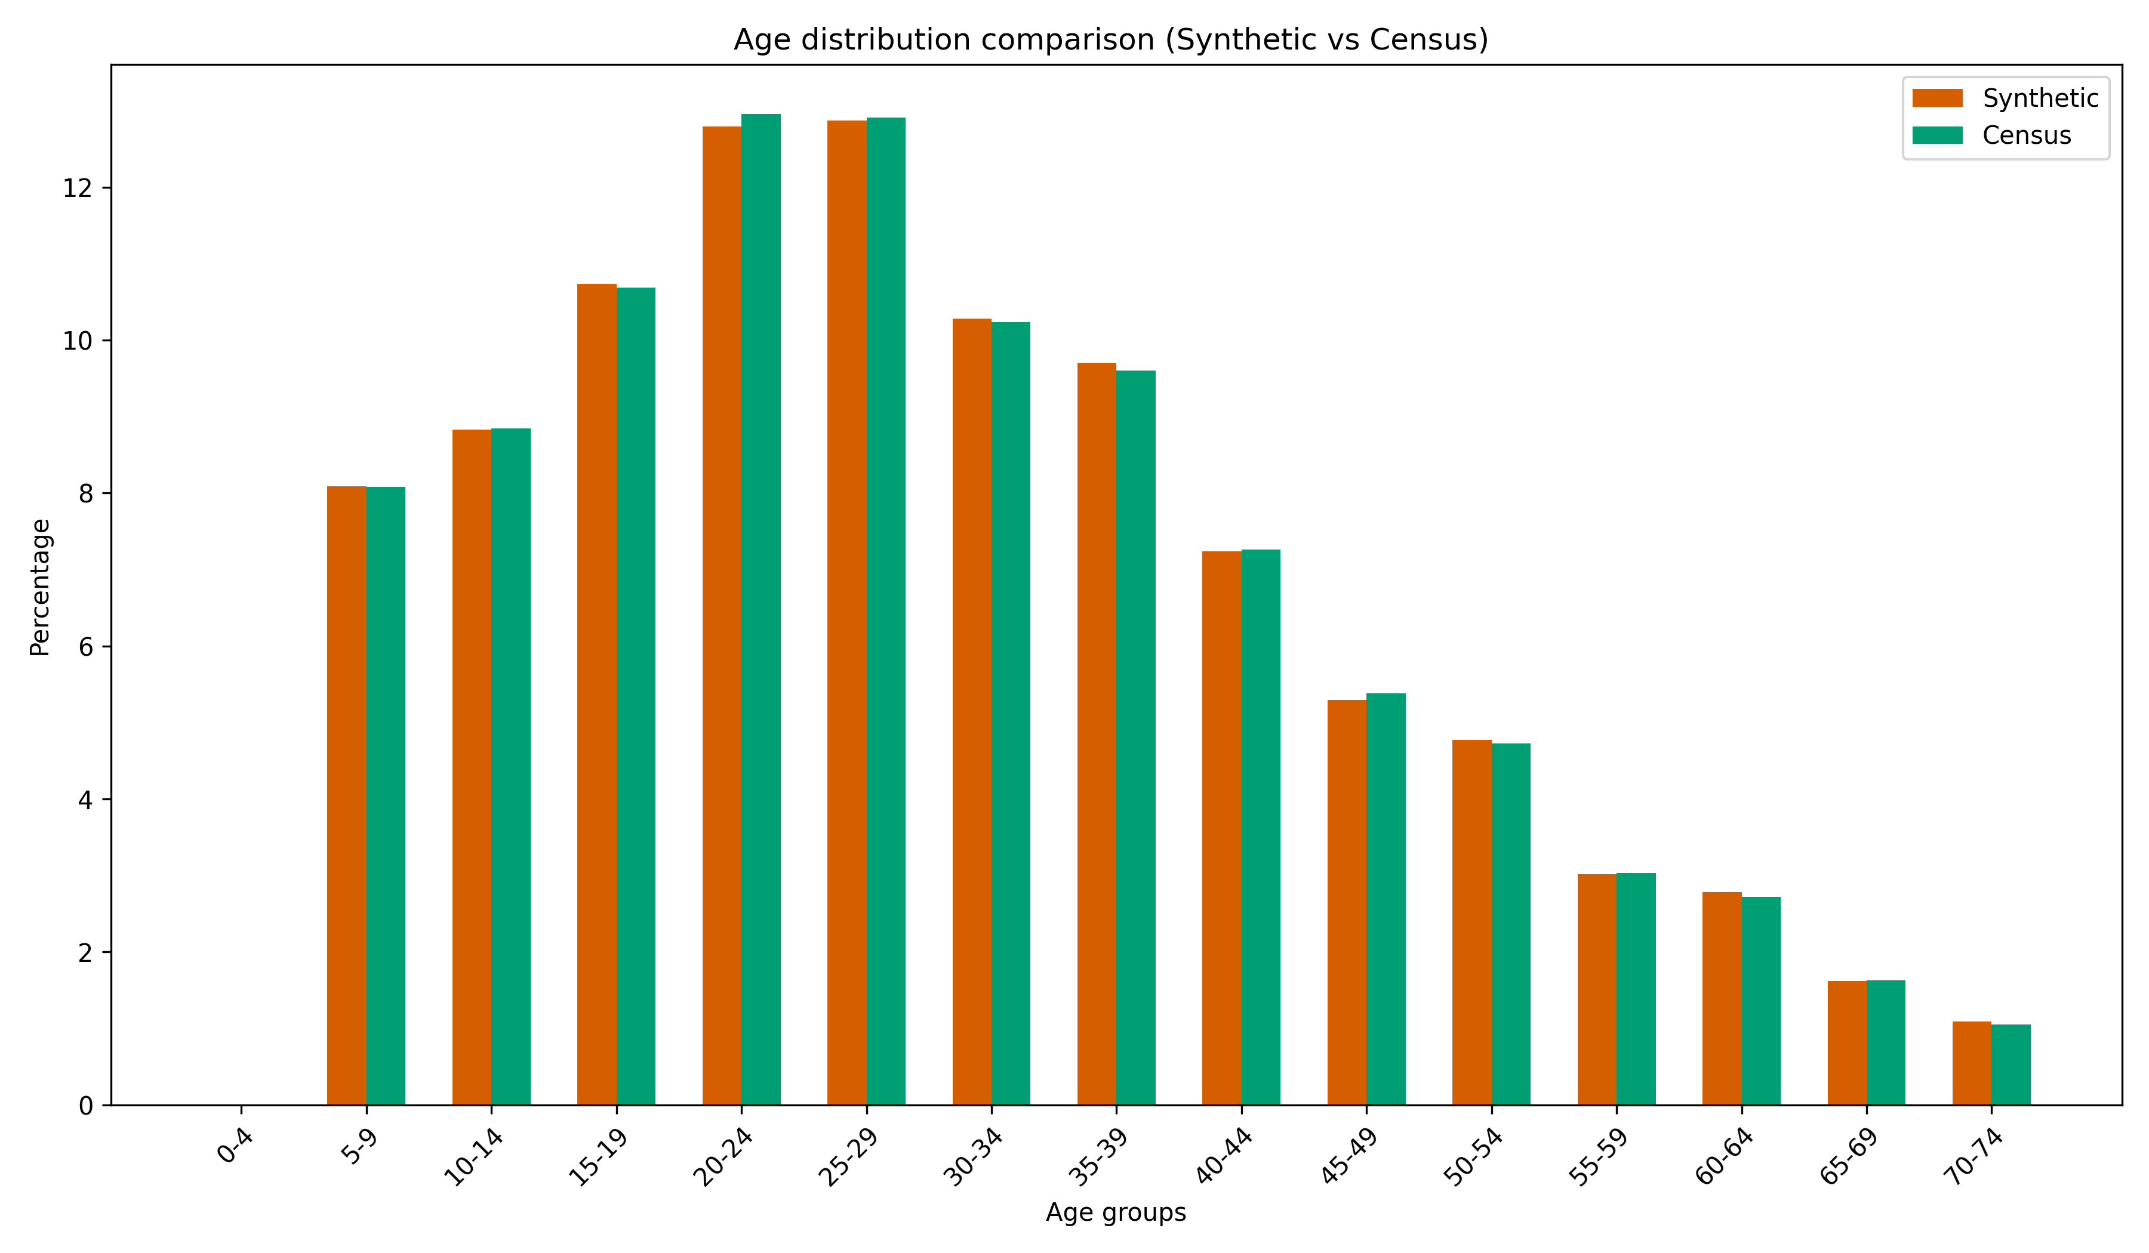
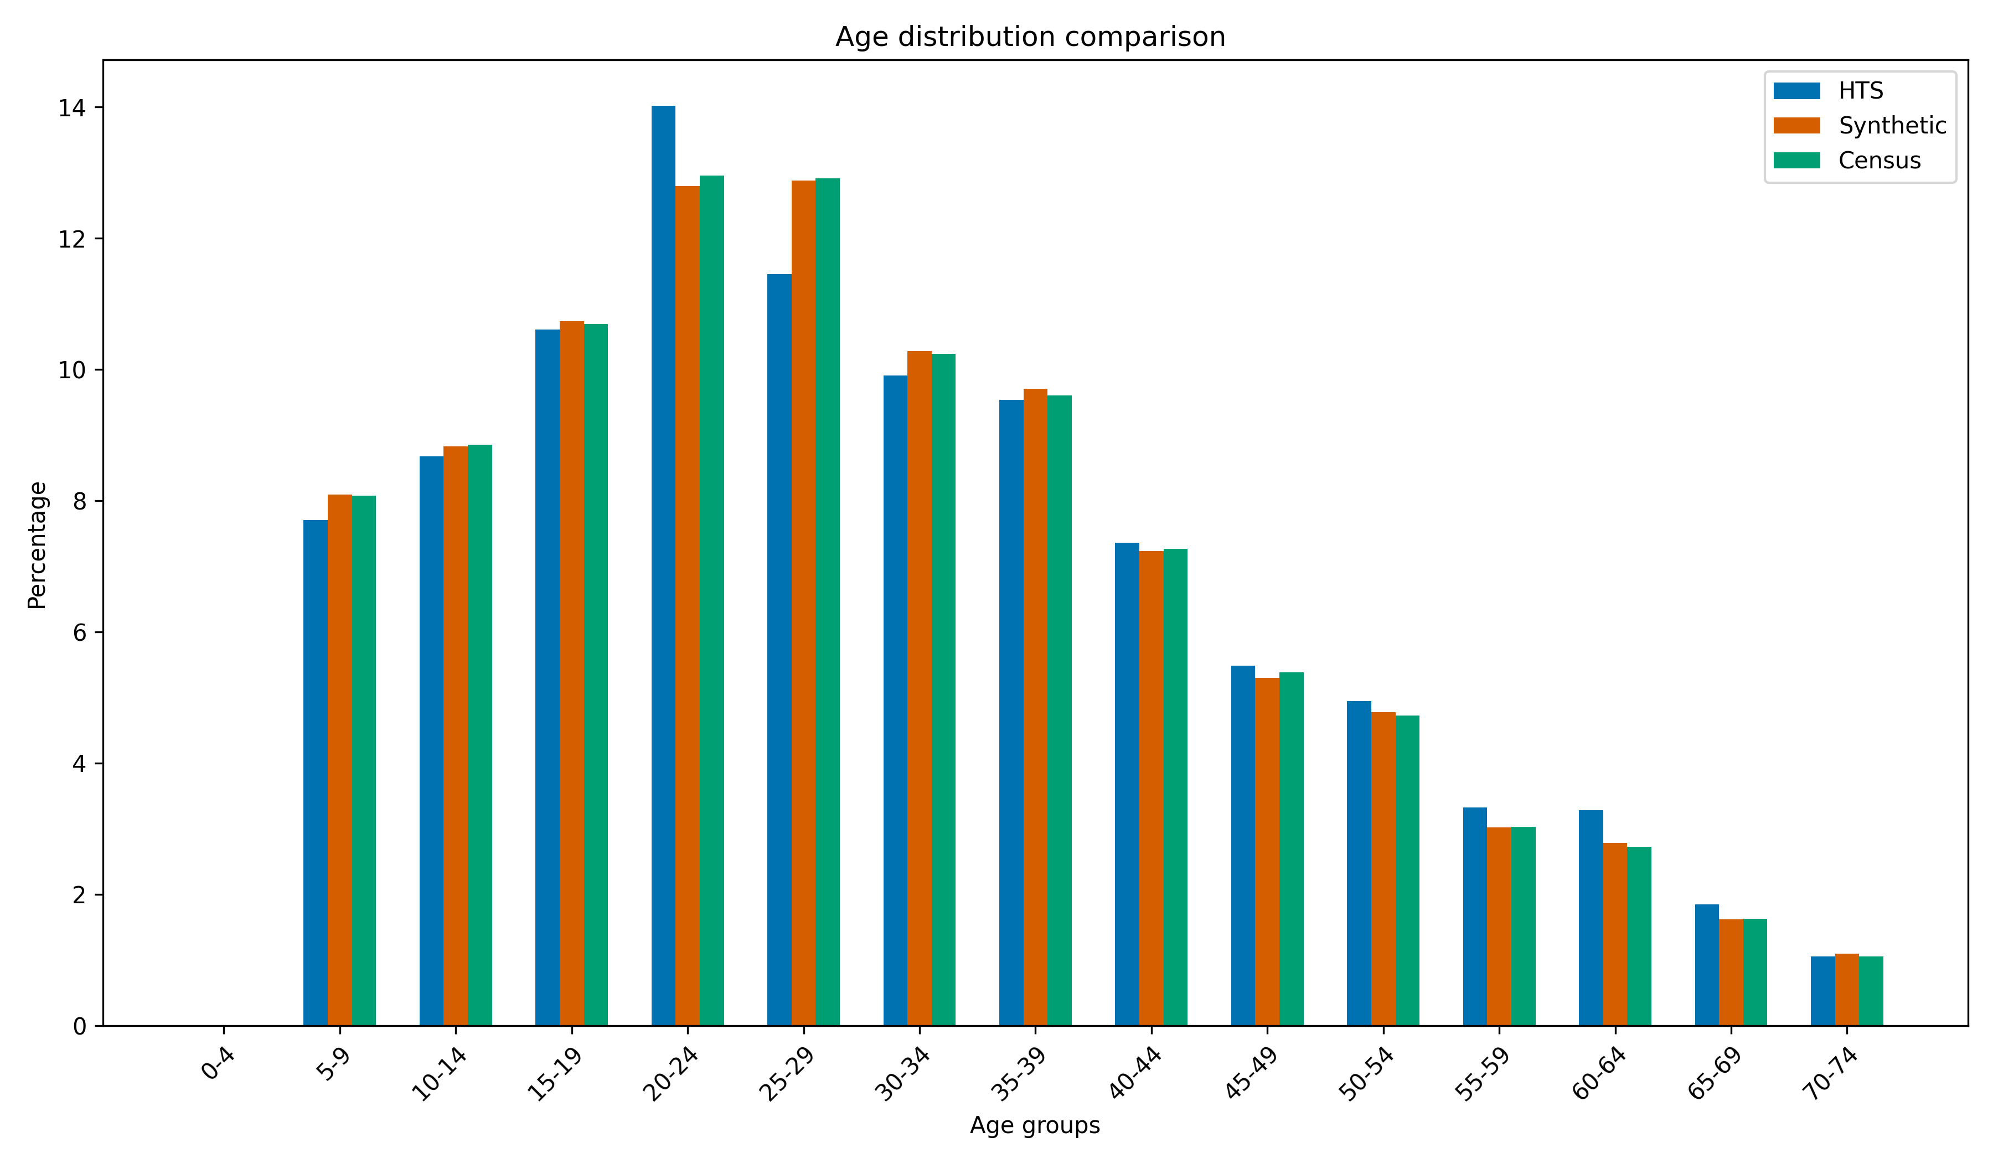
Figure 3. Age distribution (Synthetic + Census, Synthetic + HTS, Synthetic + Census + HTS)

Figure 4 compares the household size distribution across the synthesized population, the census, and the household travel survey. Unlike the age distribution, a substantial discrepancy exists between the survey and the census. The survey under-represents single-person households while over-representing three- and four-person households which is a common limitation of household travel surveys due to the lower participation of single-occupancy households. In contrast, the synthesized population closely reproduces the census distribution with deviations of less than approximately 0.15 percentage points across all household-size categories.
This agreement should be interpreted alongside the characteristics of the donor sample. The household travel survey contains only 29 single-person households and 3,313 households with five or more members among 38,092 surveyed households. Consequently, although the synthesis process accurately matches the aggregate census distribution, the limited number of donor households in these categories necessitates repeated sampling of the same household profiles. As a result, while the marginal household-size distribution is well preserved, the diversity of synthesized households within the underrepresented size categories remains constrained by the available survey data.
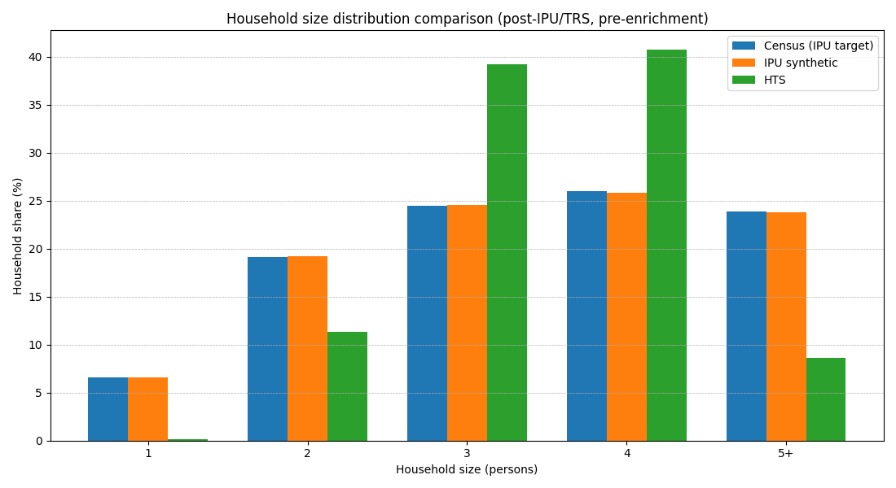
Figure 4. Household Size Comparison (Synthetic + Census + HTS)

Figures 5 and 6 compare employment status and driving-license possession between the synthesized population and the household travel survey. As no independent census benchmark is available for either attribute at the ward level, these comparisons serve as internal consistency checks rather than external validation. The synthesized population closely matches the observed survey distributions for both attributes, indicating that the population synthesis process preserves these characteristics effectively, as they are directly inherited from matched survey records rather than estimated through a parametric model.
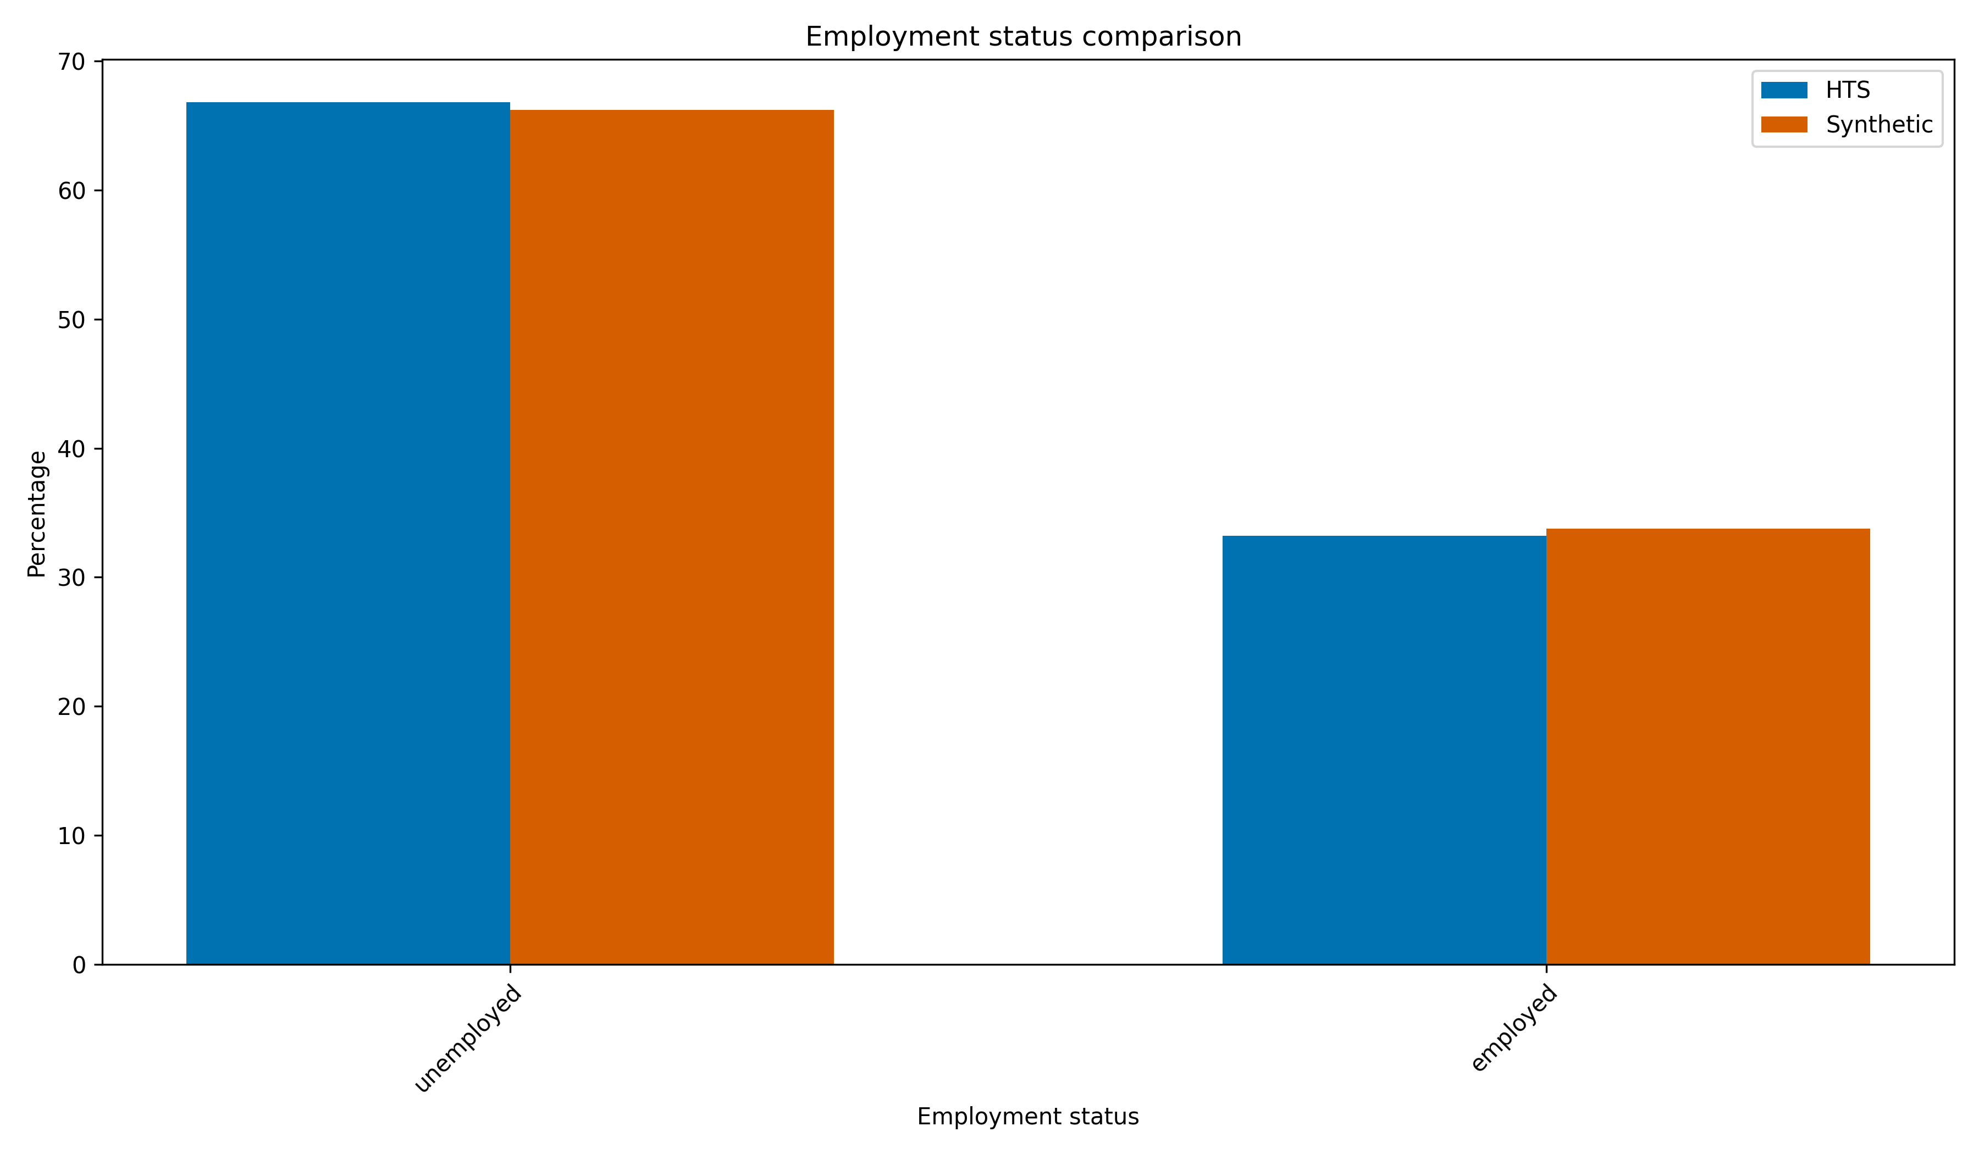
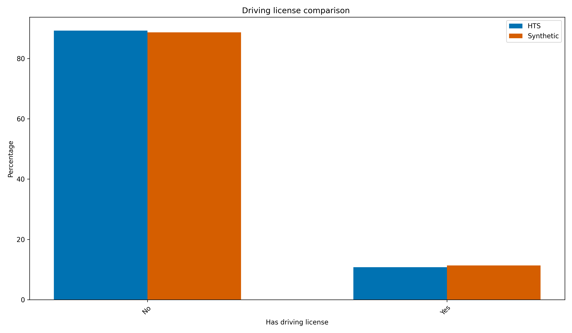

Figure 6. Driving License Comparison (Synthetic + HTS)

Figure 5. Employment Status Comparison (Synthetic + HTS)

Figure 7 compares the distribution of daily activity chains (e.g., home–work–home and home–education–home) between the synthesized population and the household travel survey. As each synthetic individual inherits an activity chain from a statistically matched survey record, the synthesized distribution closely follows the observed survey. The most frequent activity chains retain the same rank order, with only minor differences in their relative frequencies.
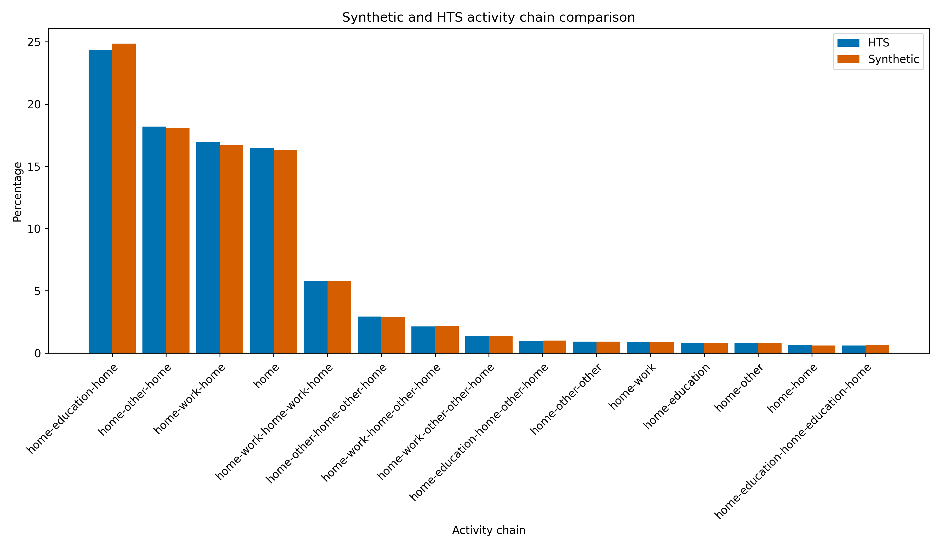
Figures 8 and 9 further compare the number of activities per daily chain and the frequency of repeated activity purposes within a chain (e.g., visiting the workplace more than once in a day). In both cases, the synthesized population closely reproduces the survey distributions, demonstrating that the matching procedure preserves not only the overall activity-chain frequencies but also their internal structure.

Figure 6. Synthetic & HTS activity Chain Comparison
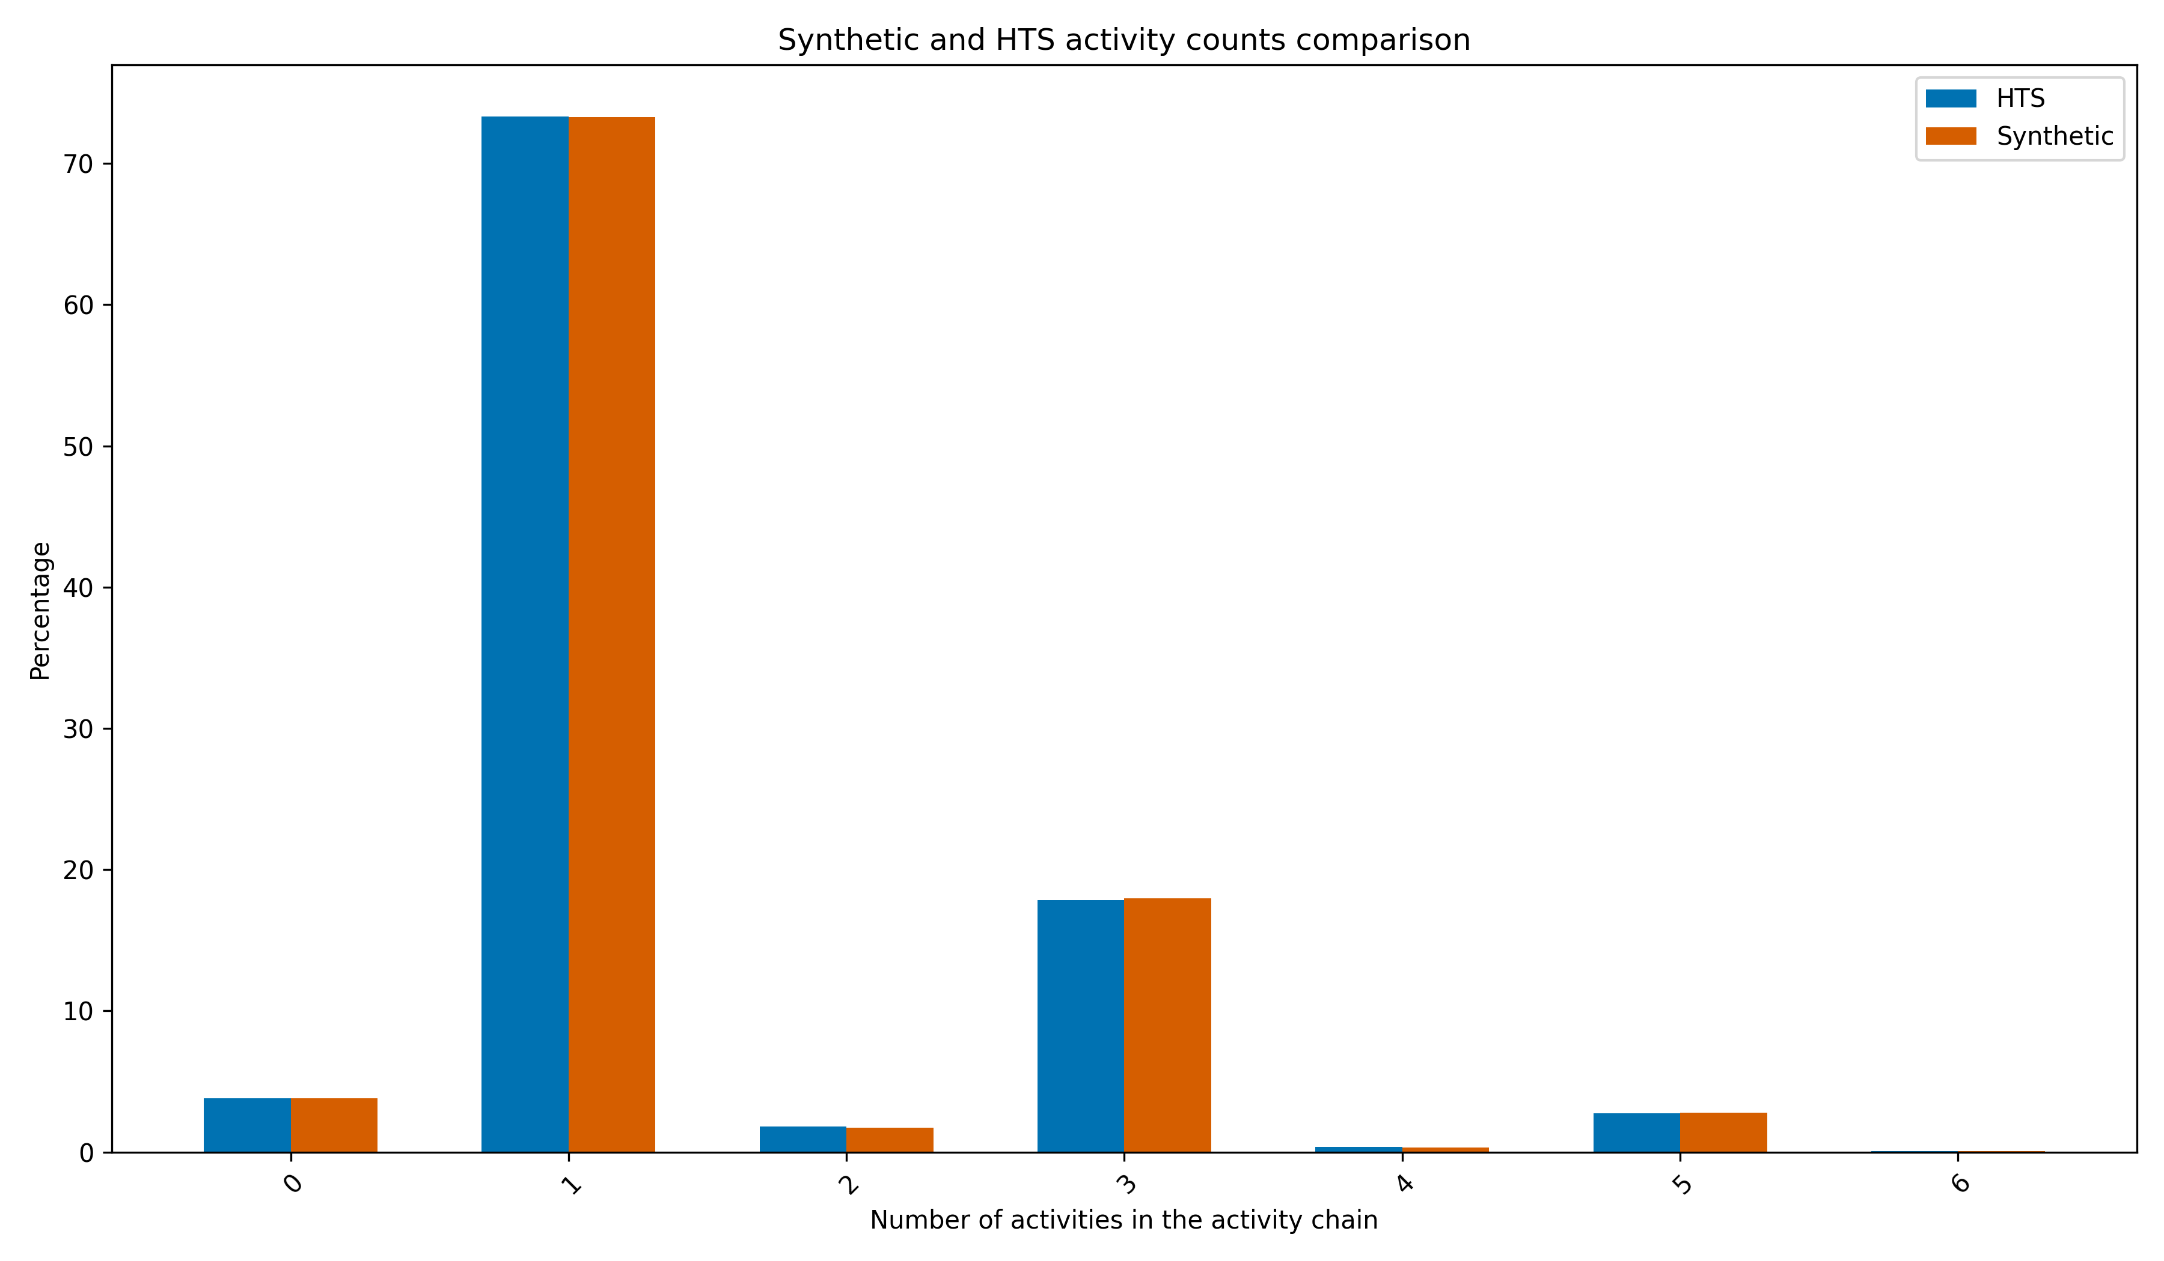
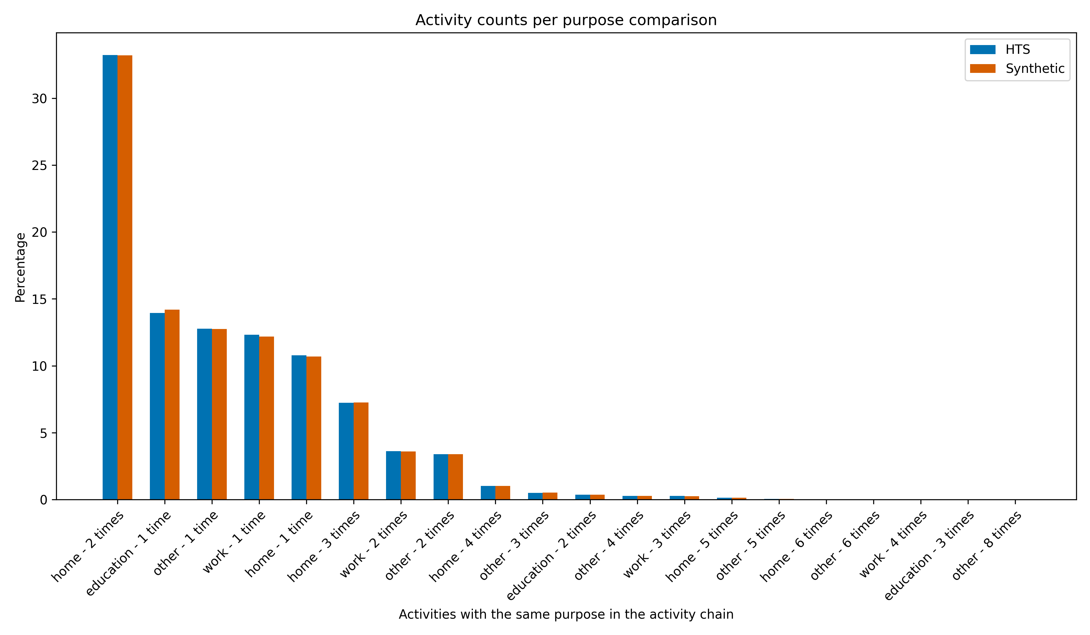

Figure 8. Activity counts per purpose comparison
Figure 9. Synthetic & HTS activity counts comparison
Figure 10 compare the crow-fly trip distance distributions between the synthesized population and the household travel survey by trip purpose. Across major trip purposes (home, work, and education) the synthesized population closely reproduces the observed distance distributions. This agreement indicates that the distance-distribution-based activity location assignment method effectively preserves the travel distance characteristics across both trip purposes.

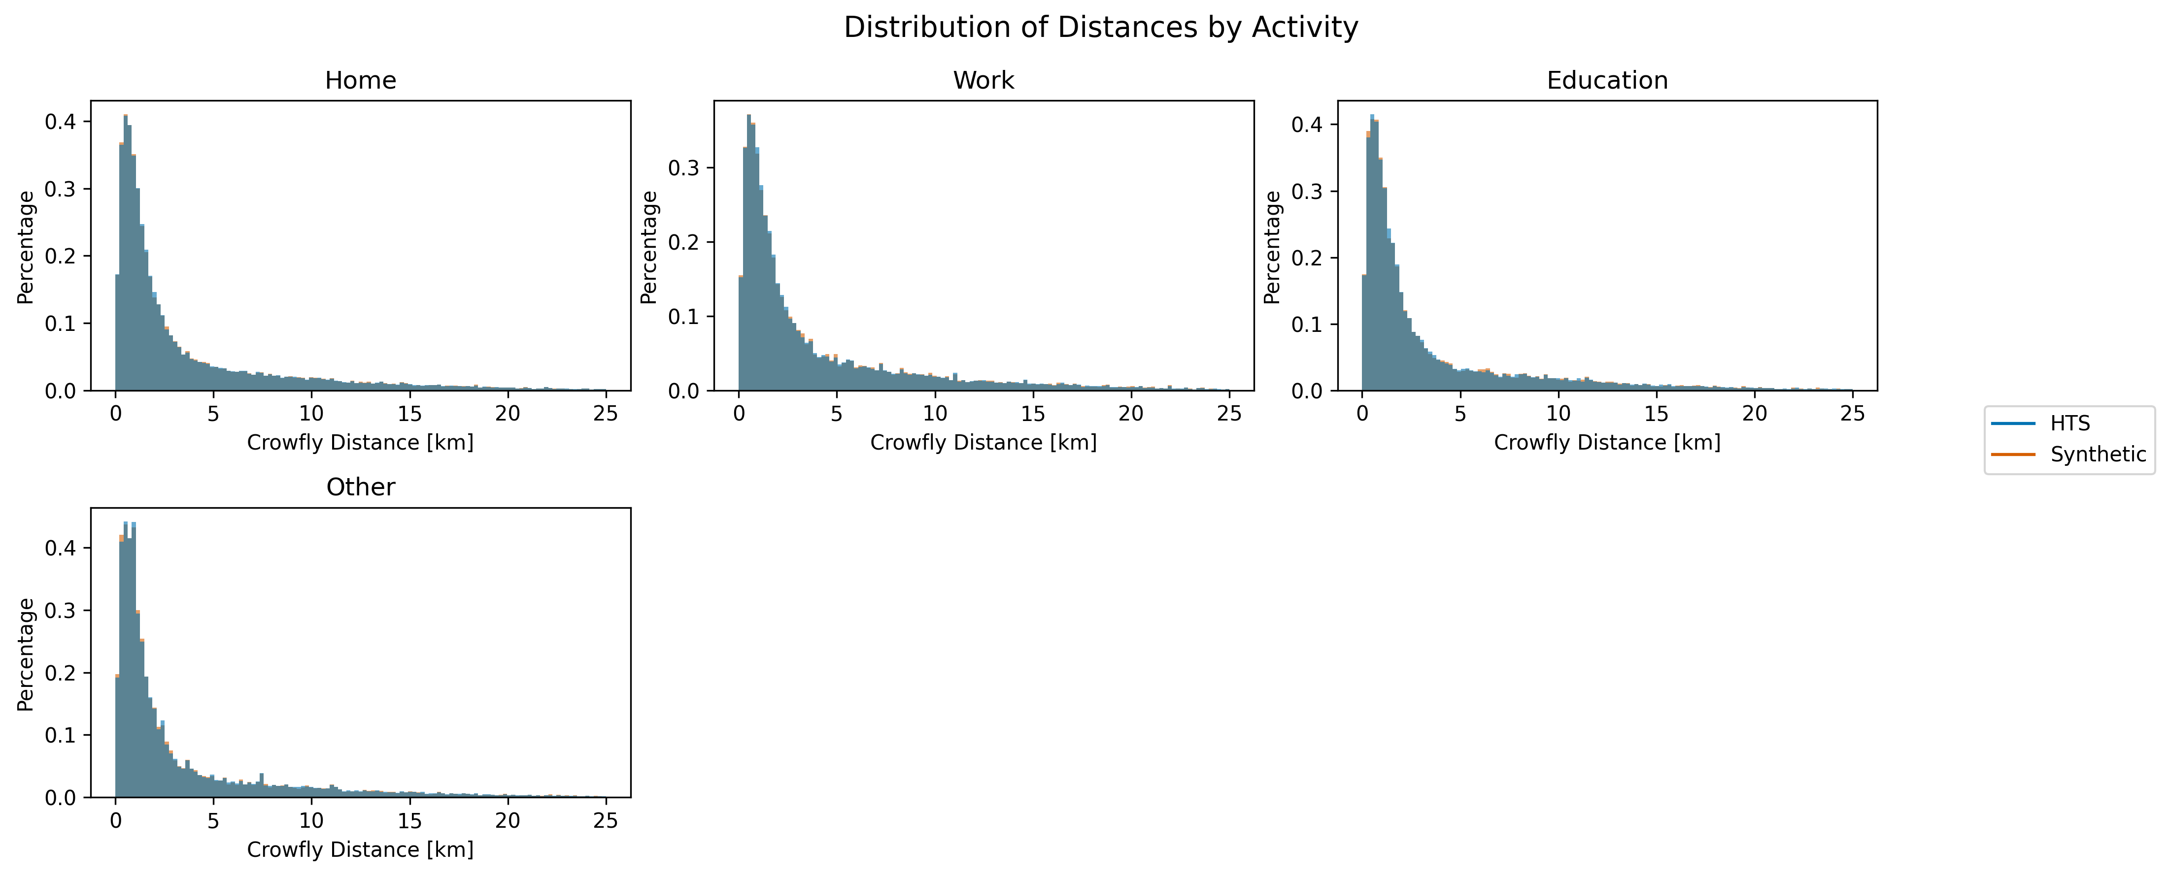
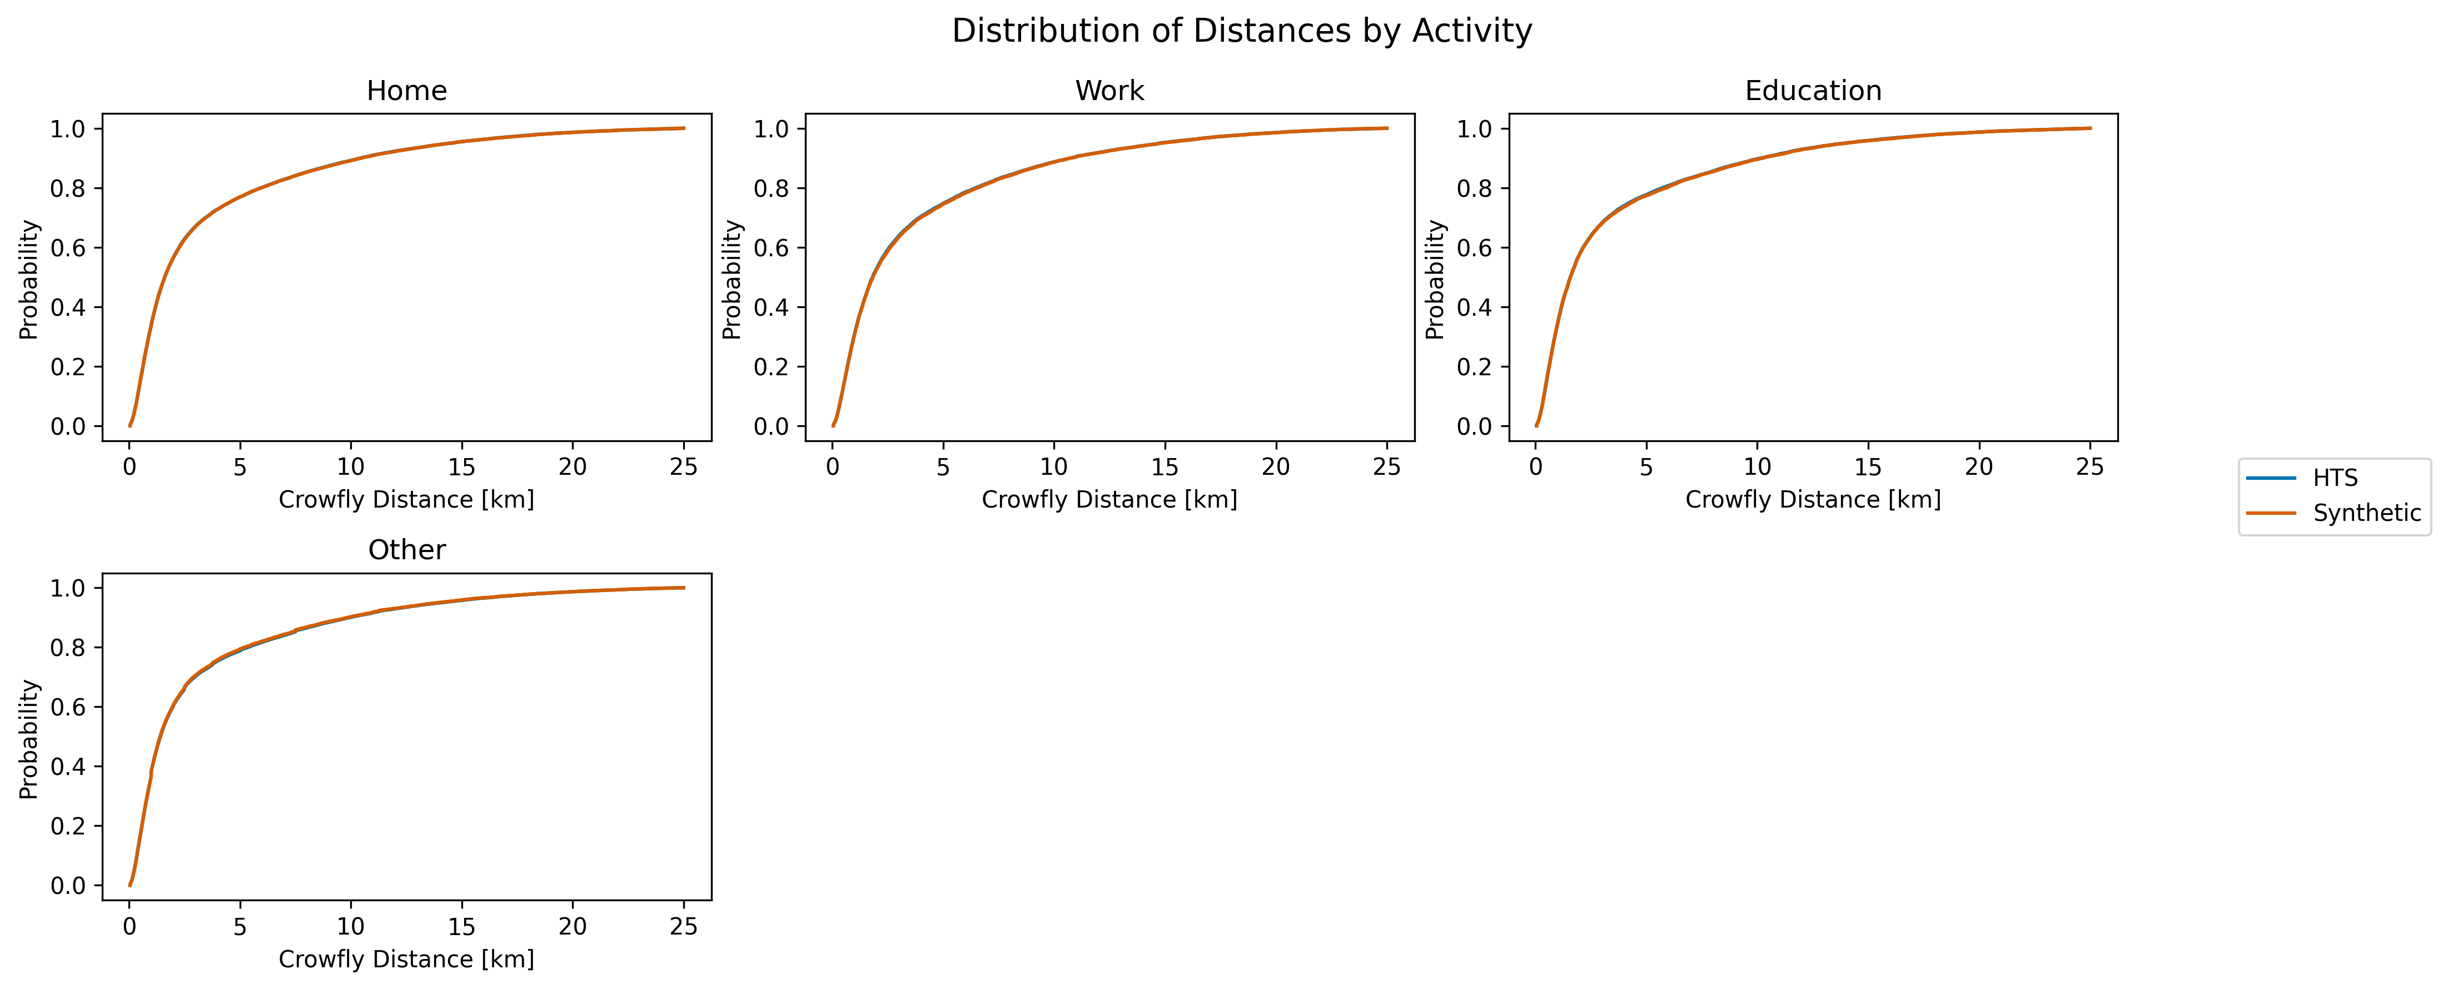
Figure 10. Distribution of Distance by Activity

7. DISCUSSION AND POLICY IMPLICATIONS
8. CONCLUSION

ACKNOWLEDGMENTS

AUTHOR CONTRIBUTIONS
DATA AVAILABILITY STATEMENT
REFERENCES
- Balać, M. and S. Hörl (2020) Synthetic population for the state of California based on open-data: examples of San Francisco Bay Area and San Diego County. Submitted for presentation at TRB 2021.
- Bangladesh Bureau of Statistics (BBS) (2022) Population and Housing Census 2022: Community Report, Dhaka. Statistics and Informatics Division, Ministry of Planning, Government of the People's Republic of Bangladesh.
- Felbermair, M. et al. (2020) [FULL CITATION NEEDED — please provide the exact title, journal/conference, volume, and pages for the Carinthia, Austria Bayesian network/MCMC study cited in the Background section].
- Hörl, S. and K.W. Axhausen (2020) Relaxation-discretization algorithm for spatially constrained secondary location assignment, paper presented at the 99th Annual Meeting of the Transportation Research Board.
- Hörl, S. and M. Balać (2021) Reproducible scenarios for agent-based transport simulation: A case study for Paris and Île-de-France.
- Horni, A., K. Nagel, and K.W. Axhausen (eds.) (2016) The Multi-Agent Transport Simulation MATSim, Ubiquity Press, London.
- Lovelace, R. and D. Ballas (2013) 'Truncate, replicate, sample': A method for creating integer weights for spatial microsimulation, Computers, Environment and Urban Systems, 41, 1–11.
- matsim-org (2016) pt2matsim: Tools to create MATSim transit schedules and networks from GTFS and OpenStreetMap data. https://github.com/matsim-org/pt2matsim
- Ortuzar, J. and L. Willumsen (2011) Modelling Transport, 4th edition.
- Pereira, [?] et al. (2022) [FULL CITATION NEEDED — please provide the exact title, journal/conference, volume, and pages for the Ustí nad Labem eqasim extension study cited in the Background section].
- Ruan, [?] et al. (2025) [FULL CITATION NEEDED — please provide the exact title, journal/conference, volume, and pages for the Washington, D.C. Digital Urban Mobility Twin study cited in the Background section].
- Sallard, A., M. Balać, and S. Hörl (2020) A synthetic population for the greater São Paulo metropolitan region. Working paper, ETH Zürich.
- Ye, X., K. Konduri, R.M. Pendyala, B. Sana, and P. Waddell (2009) A methodology to match distributions of both household and person attributes in the generation of synthetic populations, paper presented at the 88th Annual Meeting of the Transportation Research Board, Washington, DC.
- Zannat, [?] et al. (2024) [FULL CITATION NEEDED — please provide the exact title, journal/conference, volume, and pages for the Dhaka BRT MATSim mode-choice study cited in the Background section].

